Library Management System
Project: City Library | Technology: HTML, CSS, JavaScript (localStorage)

Aim
To design and develop a web-based Library Management System using HTML, CSS and JavaScript that lets admins manage books and students search, issue and return them.

Algorithm
- Start: load books, users and issue records from localStorage (seed defaults on first run).
- User opens the site and logs in (admin or student); session role decides the menu.
- Admin: add / edit / delete books and view all issued records.
- Student: search the catalog by title/author/category; check availability.
- Issue: if copies > 0, reduce copies by 1, save issue date and due date.
- Return: increase copies by 1, calculate fine if return date > due date.
- Save all changes to localStorage and re-render the page. Stop.

Result
The Library Management System was implemented successfully using HTML, CSS and JavaScript. All modules (login, role-based pages, data entry, search/booking and admin management) work correctly in the browser, and data persists using localStorage.

Implementation (Output Screenshots)
Home page
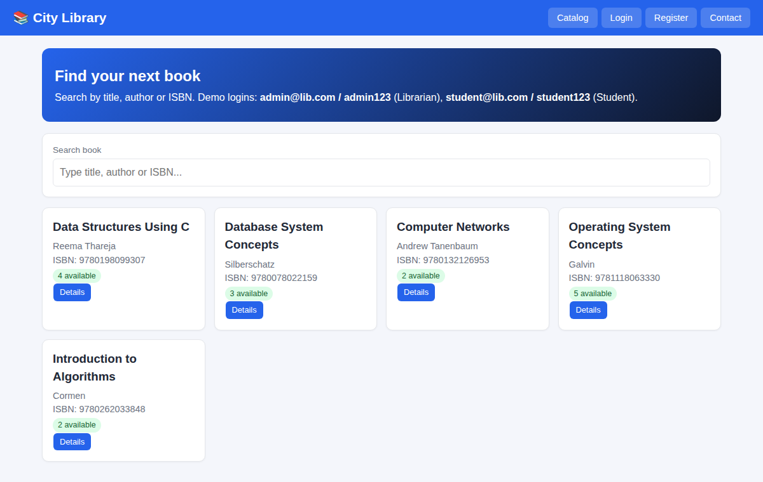
After login (admin / dashboard)
